Welcome to this mobile coding challenge and thank you for taking the time!

**Introduction**

We have selected 4 Superheroes and gathered their popularity over the years according to

the volume of Google Web Searches.

We would like you to use that data to build an App that displays the results in a Top 3.

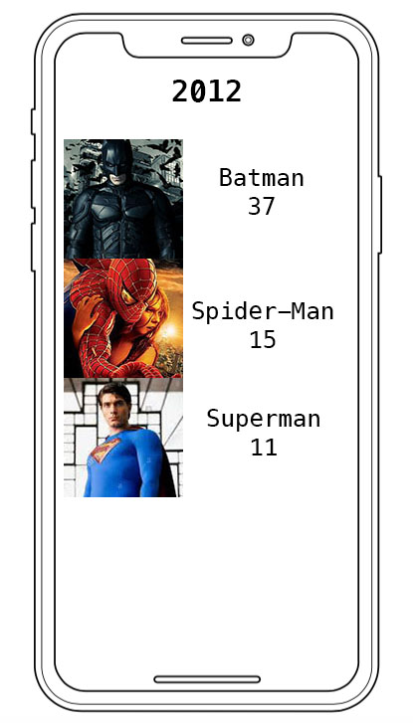

**The Data**

The 4 selected Superheroes are:

* Batman
* Superman
* Spider-Man
* Iron Man

We have collected data about them for the following years:

* 2006
* 2009
* 2012
* 2015
* 2018

That is every 3 years, starting in 2006.

We will provide both the popularity data in JSON format and Superheroes pictures.

The resources are stored in a BitBucket repository:

<https://bitbucket.org/dttden/mobile-coding-challenge/src/master/>

The raw access to these resources is available through the base URL:

*https://bitbucket.org/dttden/mobile-coding-challenge/raw/2ee8bd47703c62c5d217d9fb9e0306922a34e581/*

e.g.   
To get the data for 2006, add *2006.json* to the previous base URL and you will get:

<https://bitbucket.org/dttden/mobile-coding-challenge/raw/2ee8bd47703c62c5d217d9fb9e0306922a34e581/2006.json>

{

"Heroes":[

{

"Name":"Batman",

"Picture":"batman2004.jpeg",

"Score":11

},

{

"Name":"Superman",

"Picture":"superman1978.jpeg",

"Score":16

},

{

"Name":"Spider-Man",

"Picture":"spiderman2004.jpeg",

"Score":14

},

{

"Name":"Iron Man",

"Picture":"ironman2004.jpeg",

"Score":2

}

]

}

Name

is the Superhero name to display.

That name doesn’t change over the years.

Picture

is a picture of the Superhero in jpg format, size is 120x120px.

That picture may change over the years.

To get the full picture URL, just like for JSON files, simply add the picture name to the base URL.

e.g.

When the picture field is “batman2008.jpeg”, the URL will be:

<https://bitbucket.org/dttden/mobile-coding-challenge/raw/2ee8bd47703c62c5d217d9fb9e0306922a34e581/batman2008.jpg>

Score

is the popularity score according to Google Web Searches.

That score is very likely to change over the years.

*Notes*

The JSON is not ordered by popularity.

The name remains the same over the years.

The picture and score may change over the years.

**The Behaviour**

For each year, we would like to visualize a Top 3 most popular Superheroes.

On top of the screen, the current year for which we visualize the data is displayed.

The Superheroes data will be displayed in a Table View:

* Superhero’s name
* His Score / Popularity
* A picture of the Superhero

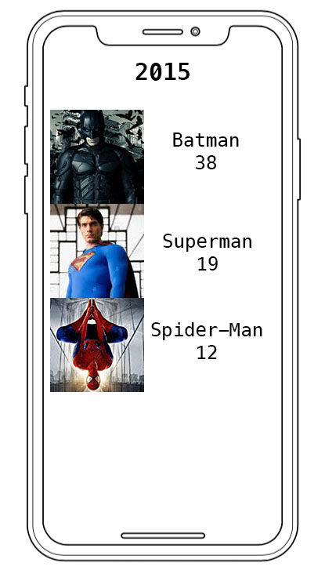

When the user pulls down (a “pull to refresh” gesture),

it moves to the following year and displays the data accordingly.

When the last year is reached (2018), cycle so that it comes back to the first one (2006).

**Rules**

* Your code should be easily accessible from a git repository (BitBucket, Github…).
* Your App should be easy to setup and test. Add instructions/readme if needed.
* Overall, we expect you to use good practices and deliver good/high quality code.
* Avoid using any third party libraries, but if you really need to, please justify your choices.

**Bonus**

These are not requirements per see, but are good to have.

In order of preference:

* Use asynchronous calls and enhanced responsiveness of your App.
* Efficient use and reuse of memory, e.g. a cache mechanism.
* Transitions between the different years.